Machining: An Introduction

In terms of annual dollars spent, machining is the most important of the manufacturing processes. Machining can be defined as the process of removing material from a workpiece in the form of chips. The term metal cutting is used when the material is metallic. Most machining has very low set-up cost compared to forming, molding, and casting processes. However, machining is much more expensive for high volumes. Machining is necessary where tight tolerances on dimensions and finishes are required.
The Machining section is divided into the following categories:
- Drilling
- Turning
- Milling
- Grinding
- Chip formation

1. Drilling

Drilling is easily the most common machining process. One estimate is that 75% of all metal-cutting material removed comes from drilling operations.
Drilling involves the creation of holes that are right circular cylinders. This is accomplished most typically by using a twist drill, something most readers will have seen before. The figure below illustrates a cross section of a hole being cut by a common twist drill:

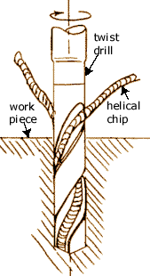
The chips must exit through the flutes to the outside of the tool. As can be seen in the figure, the cutting front is embedded within the workpiece, making cooling difficult. The cutting area can be flooded, coolant spray mist can be applied, or coolant can be delivered through the drill bit shaft.

Drilling Characteristics

The characteristics of drilling that set it apart from other powered metal cutting operations are:

- The chips must exit out of the hole created by the cutting.
- Chip exit can cause problems when chips are large and/or continuous.
- The drill can wander upon entrance and for deep holes.
- For deep holes in large workpieces, coolant may need to be delivered through the drill shaft to the cutting front.
- Of the powered metal cutting processes, drilling on a drill press is the most likely to be performed by someone who is not a machinist.

Drill Press Work Area

A view of the metal-cutting area of a drill press is shown below. The workpiece is held in place by a C-clamp since cutting forces can be quite large. It is dangerous to hold a workpiece by hand during drilling since cutting forces can unpredictably get quite large and wrench the part away. Wood is often used underneath the part so that the drill bit can overshoot without damaging the table. The table also has holes for drill overshoot as well as weight reduction. A three-jaw chuck is used since three points determine a circle in two dimensions. Four-jaw chucks are rarely seen since offset of the bit is not necessary. The next section contains illustrations of drill bit chucks. To get an idea of the differing configurations of three and four-jaw chucks.

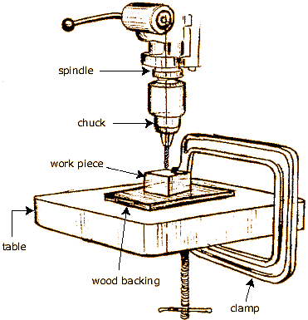

2. Turning: Engine Lathe

Turning is another of the basic machining processes. Information in this section is organized according to the subcategory links in the menu bar to the left.
Turning produces solids of revolution which can be tightly toleranced because of the specialized nature of the operation. Turning is performed on a machine called a lathe in which the tool is stationary and the part is rotated. The figure below illustrates an engine lathe. Lathes are designed solely for turning operations, so that precise control of the cutting results in tight tolerances. The work piece is mounted on the chuck, which rotates relative to the stationary tool.

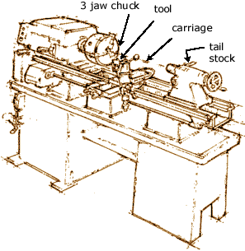
Turning

Turning refers to cutting as shown below.

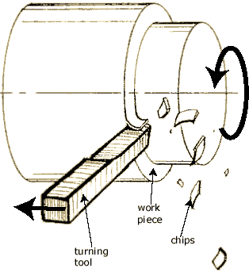
The term "facing" is used to describe removal of material from the flat end of a cylindrical part, as shown below. Facing is often used to improve the finish of surfaces that have been parted.
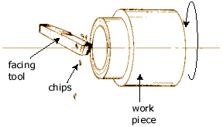
3. Milling: Introduction

Milling is as fundamental as drilling among powered metal cutting processes.
Milling is versatile for a basic machining process, but because the milling set up has so many degrees of freedom, milling is usually less accurate than turning or grinding unless especially rigid fixturing is implemented.
For manual machining, milling is essential to fabricate any object that is not axially symmetric. There is a wide range of different milling machines, ranging from manual light-duty Bridgeports™ to huge CNC machines for milling parts hundreds of feet long. Below is illustrated the process at the cutting area.

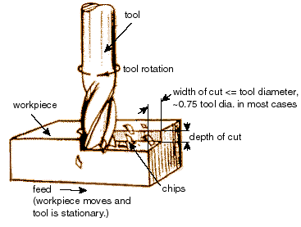
Milling: Column-and-Knee Manual Mill

Below is illustrated a typical column-and-knee type manual mill. Such manual mills are common in job shops that specialize in parts that are low volume and quickly fabricated. Such job shops are often termed "model shops" because of the prototyping nature of the work.

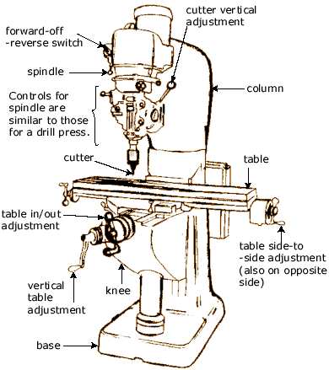
The parts of the manual mill are separated below. The knee moves up and down the column on guideways in the column. The table can move in x and y on the knee, and the milling head can move up and down.

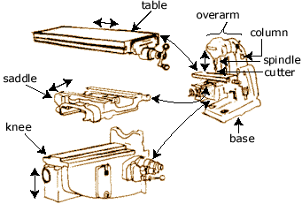

4. Grinding: Introduction

Grinding is a finishing process used to improve surface finish, abrade hard materials, and tighten the tolerance on flat and cylindrical surfaces by removing a small amount of material. Information in this section is organized according to the subcategory links in the menu bar to the left.
In grinding, an abrasive material rubs against the metal part and removes tiny pieces of material. The abrasive material is typically on the surface of a wheel or belt and abrades material in a way similar to sanding. On a microscopic scale, the chip formation in grinding is the same as that found in other machining processes. The abrasive action of grinding generates excessive heat so that flooding of the cutting area with fluid is necessary.

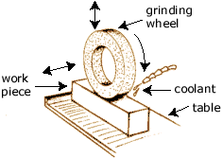

Reasons for Grinding

Reasons for grinding are:
- The material is too hard to be machined economically. (The material may have been hardened in order to produce a low-wear finish, such as that in a bearing raceway).
- Tolerances required preclude machining. Grinding can produce flatness tolerances of less than ±0.0025 mm (±0.0001 in) on a 127 x 127 mm (5 x 5 in) steel surface if the surface is adequately supported.
- Machining removes excessive material.

5. Chip Formation: Introduction

Because of the importance of machining for any industrial economy, Machining Theory has been extensively studied.
The chip formation process is the same for most machining processes, and it has been researched in order to determine closed-form solutions for speeds, feeds, and other parameters which have in the past been determined by the "feel" of the machinist.
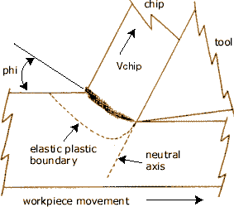
With CNC machine tools producing parts at ever-faster rates, it has become important to provide automatic algorithms for determining speeds and feeds. The information presented in this section are some of the more important aspects of chip formation. Reasons for machining being difficult to analyze and characterize can be summarized as follows:

- The strain rate is extremely high compared to that of other fabrication processes.
- The process varies considerably depending on the part material, temperature, cutting fluids, etc.
- The process varies considerably depending on the tool material, temperature, chatter and vibration, etc.
- The process is only constrained by the tool cutter. Unlike other processes such as molding and cold forming which are contained, a lot of variation can occur even with the same configuration.

For all types of machining, including grinding, honing, lapping, planing, turning, or milling, the phenomenon of chip formation is similar at the point where the tool meets the work.
Below are illustrated categories of chip types.
